Open Data Impact

Since the start of the open data movement, thousands of public datasets were opened across Europe enabling new applications and insights. Moreover, it started a switch of mindset about public data as a common good - similar to infrastructure - to enable a fair and thriving European economy. Open data became a vital part of the European digital agenda and Member States implemented their national strategies accordingly.

The economic impact that was expected to be high and very tangible turned out to be more incremental and not immediately visible because it is subtle and sometimes well hidden. The benefits of open data are created by insights that enrich research and inform decision-making, by services in the form of apps and websites, by improved products and processes that increase productivity and efficiency, wellbeing, health, safety, and sustainability. Quantifying the benefits to express the economic impact of open data is comparably complex because the most important and significant benefits are indirect.

Similar to infrastructure, open data is an enabler for the economy. As an enabler, its impact cannot be measured by simply taking into account the costs for - to stay with the infrastructure analogy – construction of roads, canals, airports, train stations, and revenues created by tolls. The value lies in the fact that people, organisations, and products are enabled to move from A to B as well as in people, organisations, and products that are needed and used to do so. Even if one does not know how to sail a big ship and has no intention to ever sail on one, she may still benefit from the goods shipped on these ships. She surely benefits from the employment generated by the cargo shipping company, the tax they pay and that returns to her translated into public spending and economic stability.

For the realisation and maintenance of a new infrastructure project, for example in energy and water supply, the social, economic, environmental and political risks, costs, and benefits are explored, quantified, and weighted. The same logic applies to the realisation and maintenance of open data projects: the benefits have to be explored and quantified to give a reasonable insight into its value compared to costs of resources. Furthermore, it increases our understanding of where it is most beneficial to allocate resources.

If we understand the economic benefit, we can keep open data high on the political agenda. It helps to communicate more clearly that making data open is not an altruistic act of charity but a vital contribution to enable a growing, innovative, ethical economy as a vital pillar for, democracy, safety and welfare.

Similar to looking at our transport network in a holistic way when planning how to move from Prague to Dublin, this report looks at data from a holistic perspective. Just like a road to a place in no-man’s-land can seem of little value, if at the end of that road a harbour or an airport is located, this road is crucial. In the same way, open data on diagnostics and health statistics linked to a personal health record can be crucial to understand symptoms.

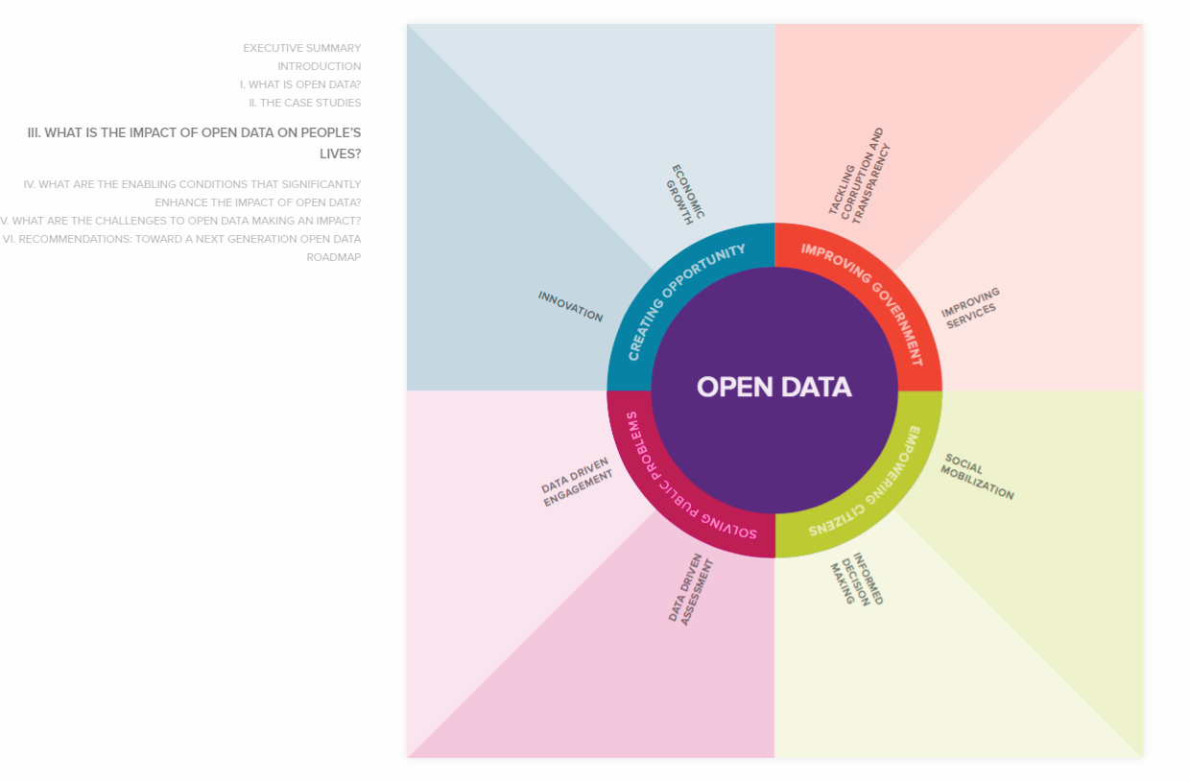

<https://odimpact.org/key-findings.html>

See methodology